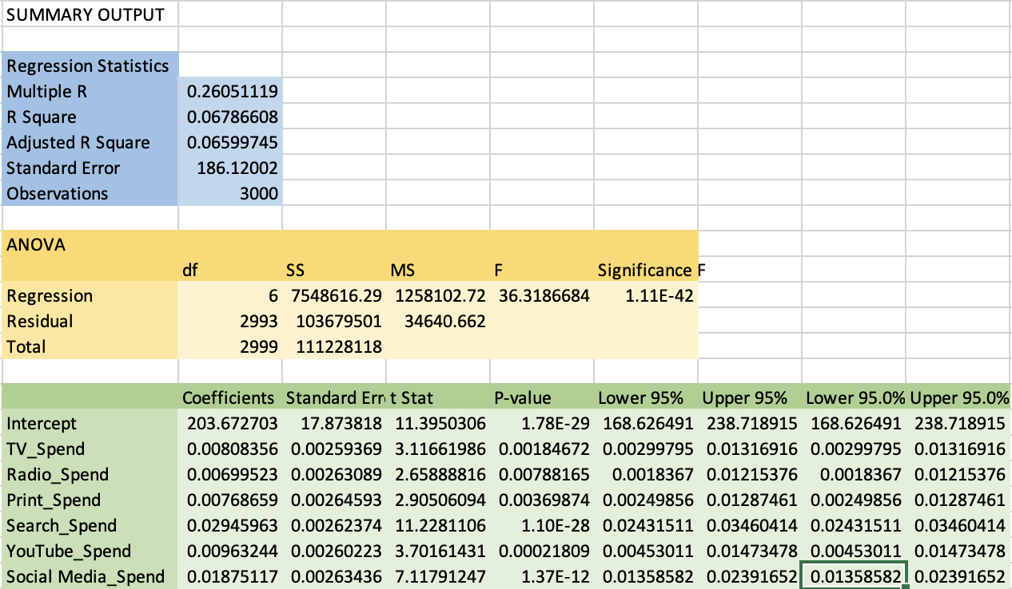

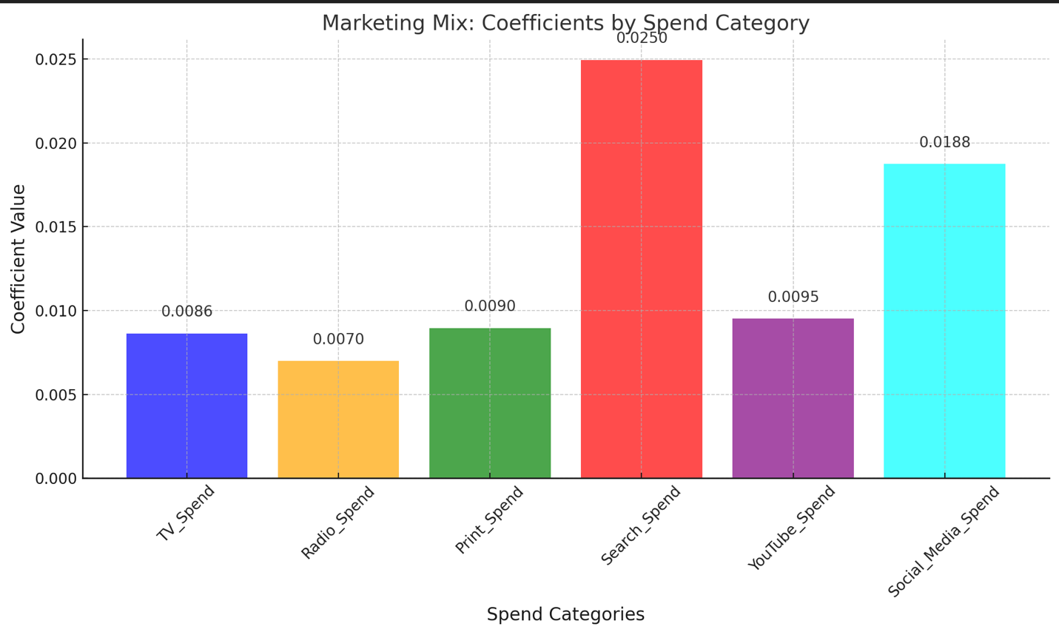

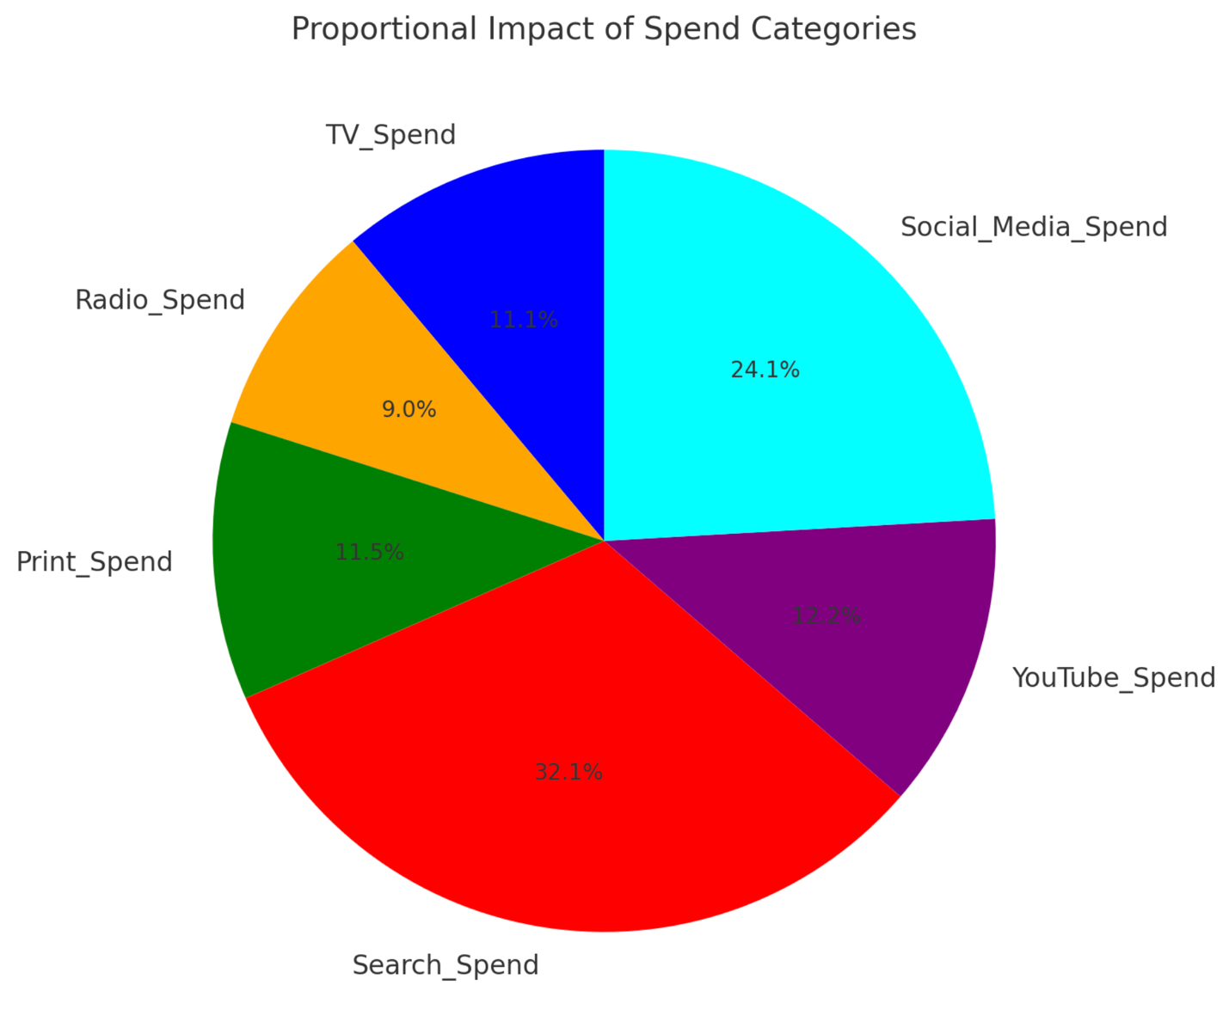

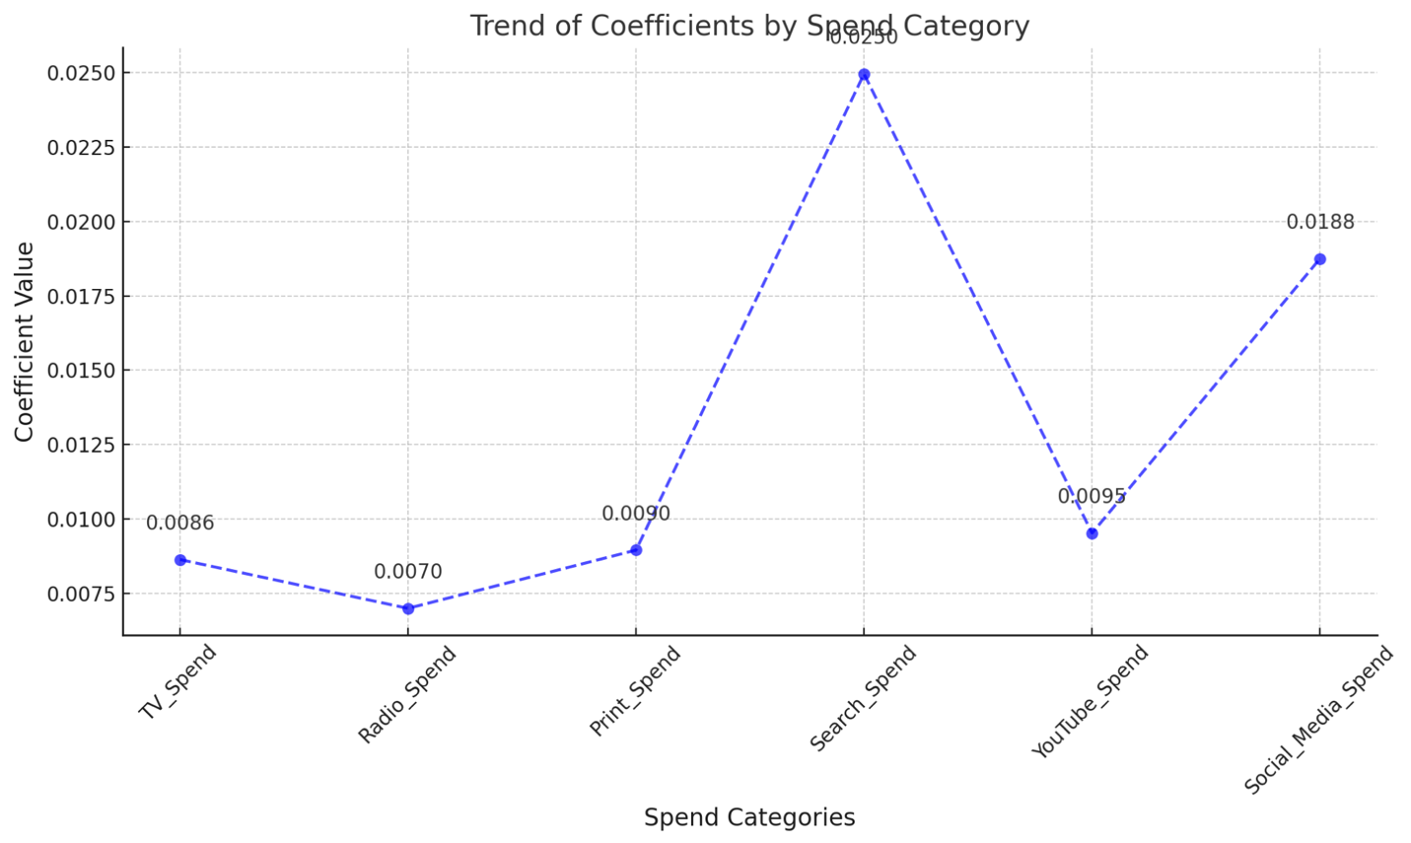

**Key Recommendations**

1. **Invest More in Search and Social Media Spend:**
   * These categories show the highest influence on the outcome and should be prioritized in the marketing budget.
2. **Optimize YouTube Spend:**
   * While impactful, its effectiveness is lower than expected. Focus on optimizing campaigns to increase ROI.
3. **Leverage TV and Print Strategically:**
   * TV and Print have moderate contributions and can complement the digital channels in reaching wider demographics.
4. **Re-evaluate Radio Spend:**
   * Radio has the least influence, so resources could be redirected to higher-impact categories.